**Calculus-I Assignment-1**

**Jeevan Neupane(19803)**

**#Question-1:**

**#Solution-1a:**

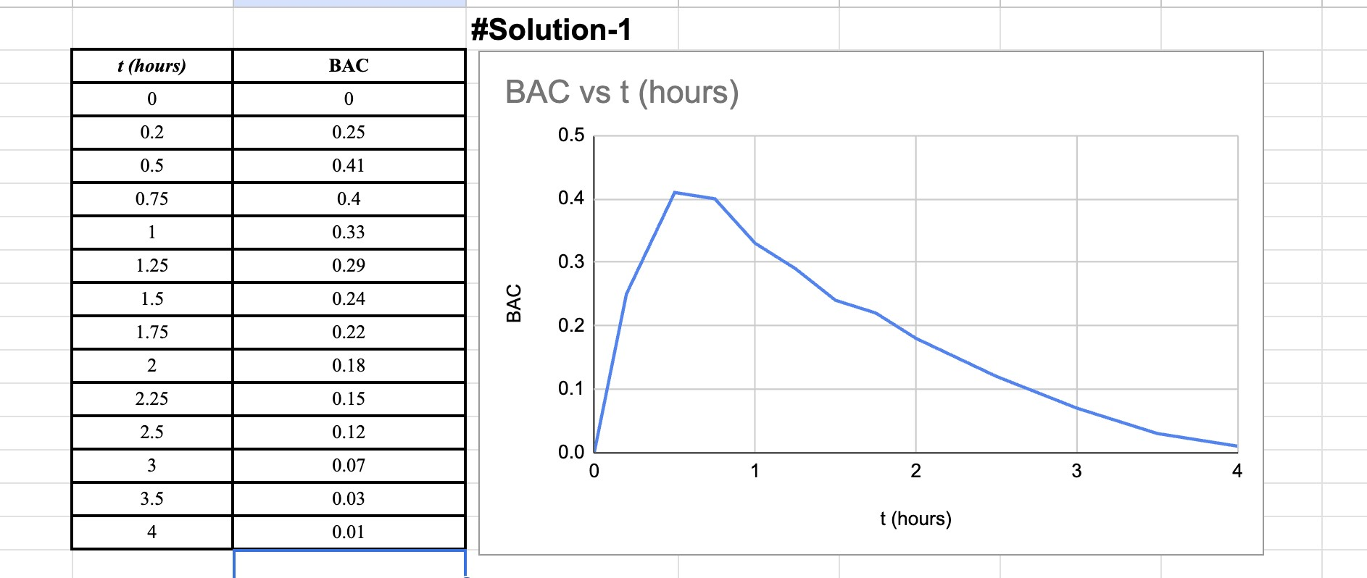

**1b:**

Now we get that after consuming alcohol rapidly, the BAC initially rises quickly, peaks at 0.41 mg/mL within half an hour, and then gradually decreases. The absorption rate slows down, leading to a slower decline in BAC over time until it reaches a negligible level after approximately 4 hours.

**#Question-2:**

**#solution:**

First let’s rearrange the equation, to find the expression for function f(x)

Given equation: 𝑥2 2

+

(

𝑦

−

2

)

4

=

4

=

(

𝑦

−

2

)

4

=

±

𝑥

(

Rearranging the equation: 4-

𝑦 − 2) √4-2𝑥2

=

2

±

𝑦

4

4

−

𝑥

From

here

we

can

see

that,

=

2

+

𝑦

4

4

−

𝑥

2

OR

=

2

-

𝑦

4

4

−

𝑥

2

**#Question-3**

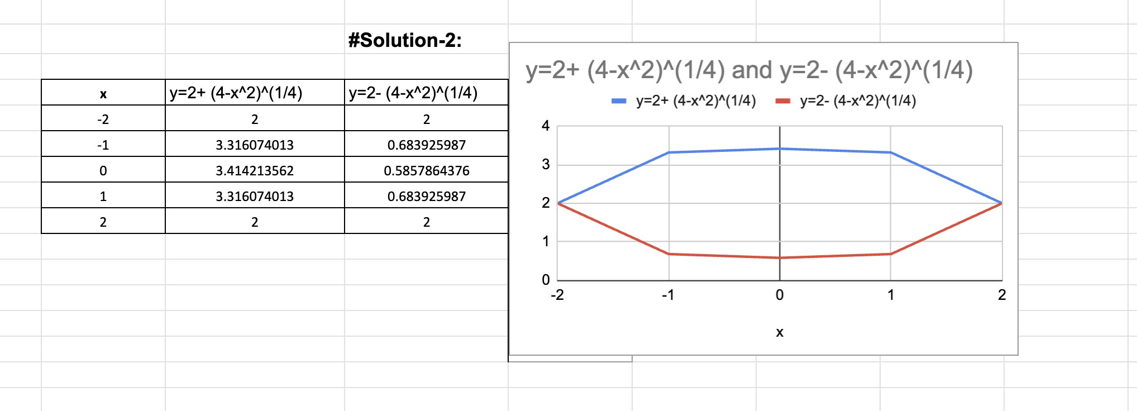

**#Solution-3a:**

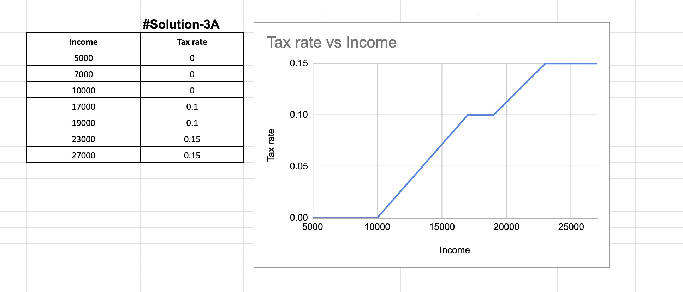

**3b:**

Let's calculate the tax assessed on an income of $14,000,

First, we have to determine the taxable amount by subtracting the non-taxable portion so

=$(14,000 - 10,000)

=$4,000

The taxable amount of $4,000 is multiplied by the tax rate of 10% (0.10) to obtain the tax assessed: $4,000 * 0.10 = $400.

Similarly, for an income of $26,000,

=$(26,000 - 10,000)

=$16,000

For the first portion of $10,000, taxed at a rate of 10%, the tax assessed is calculated as $10,000 * 0.10 = $1,000.

For the remaining amount of $6,000, taxed at a rate of 15%, the tax assessed is obtained by multiplying $6,000 by 0.15: $6,000 * 0.15 = $900.

Finally, the two tax amounts are summed up to get the total tax assessed:

$1,000 + $900 = $1,900.

**#Solution-3c:**

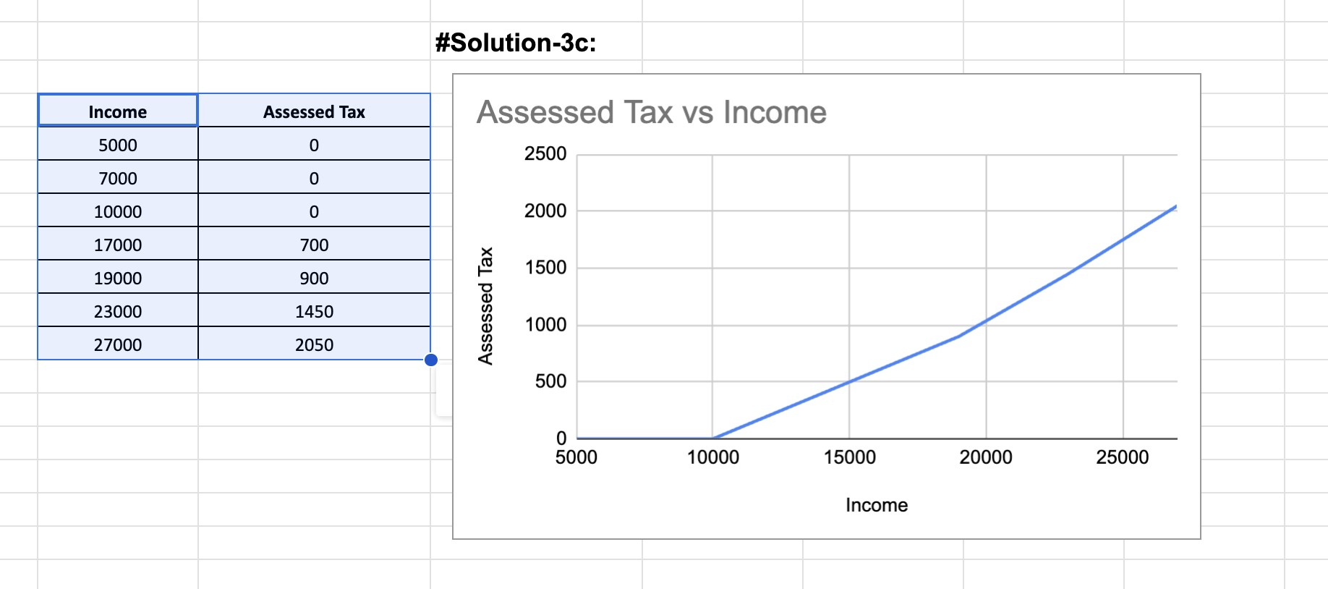

**-4:**

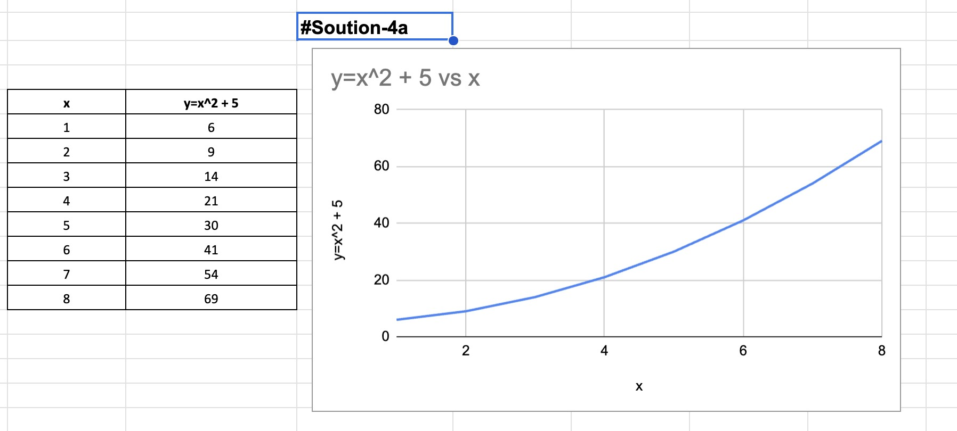

**#Solution-4b:**

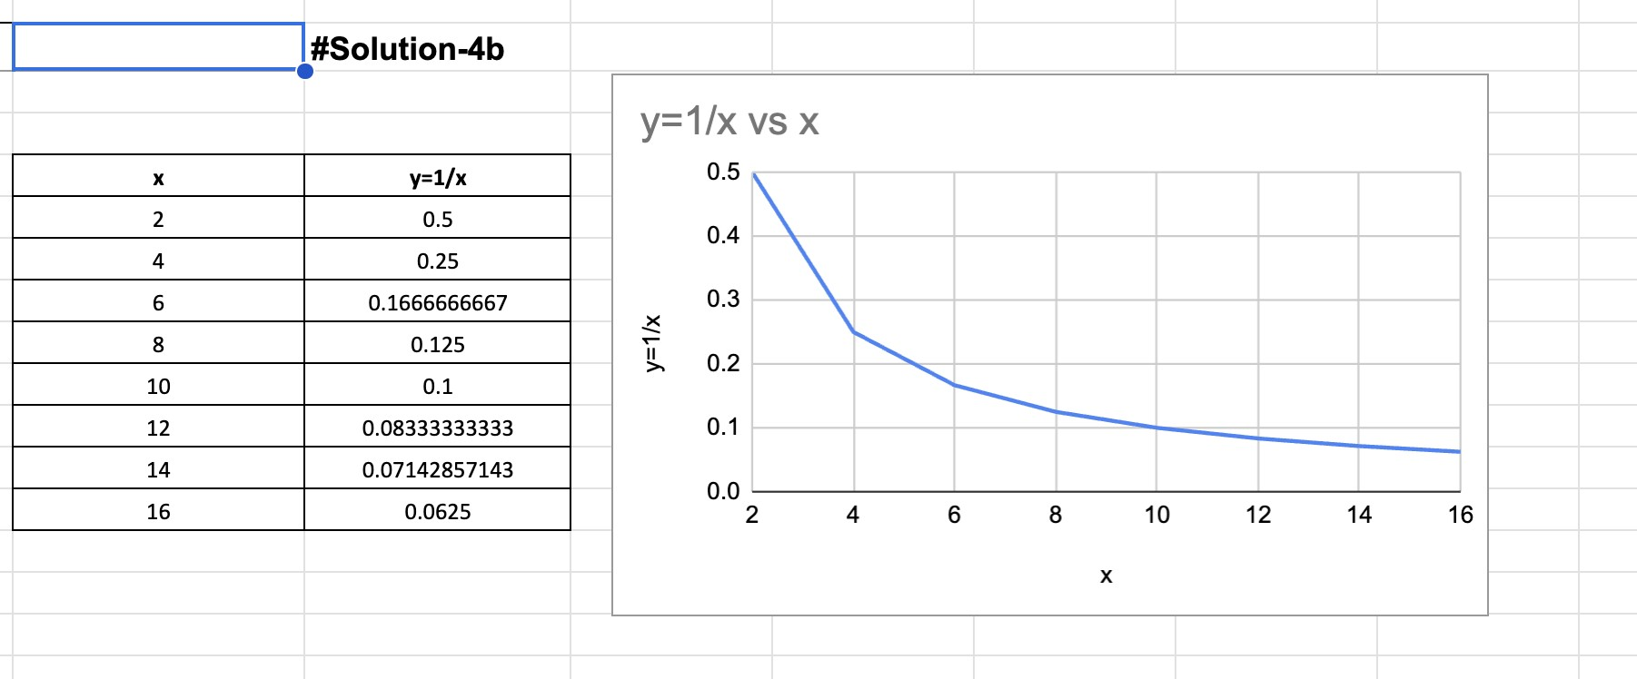

**#Question-5:**

**#Solution-5a:**

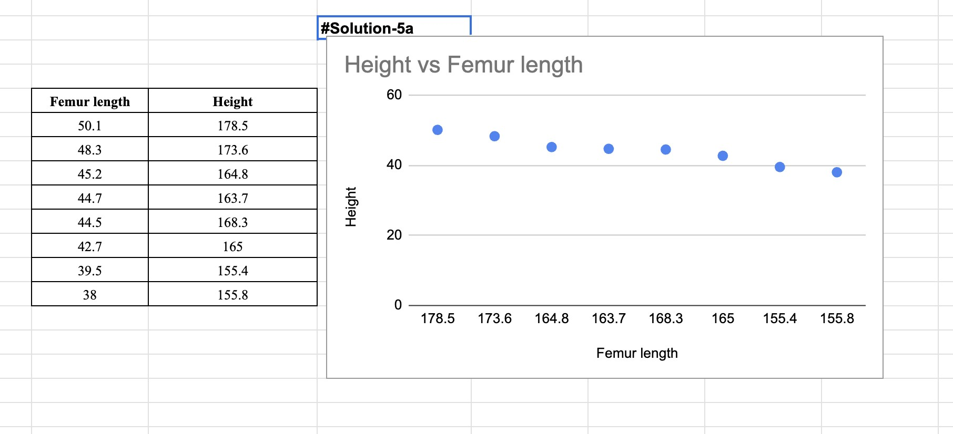

**#Solution-5b:**

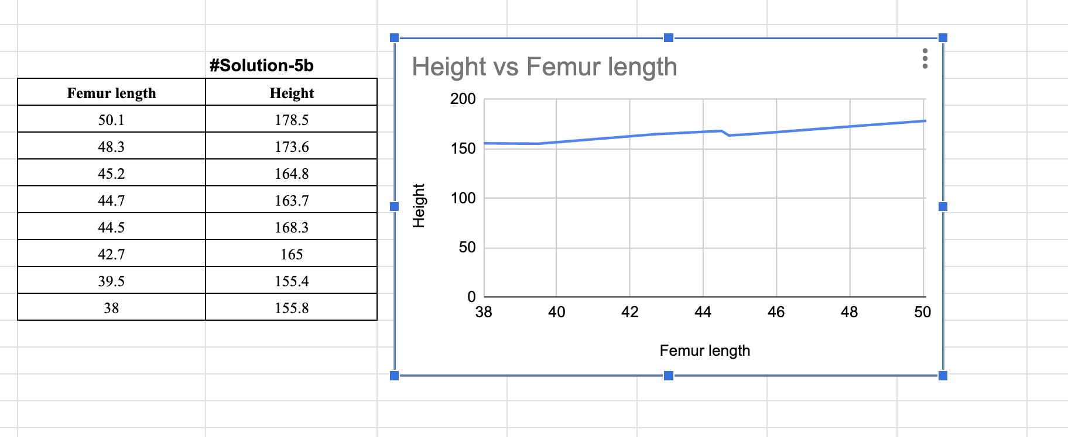

**#Solution-5c:**

Considering the given equation: y = 1.8807x + 82.65, where y represents the height and x represents the femur length.

Given that the femur length (x) is 53 cm, we can substitute this value into the equation to find the corresponding height (y).

By plugging in x = 53, we get or, y = 1.8807 * 53 + 82.65 or, y = 99.7871 + 82.65 y = 182.4371 cm

Therefore, the person's height is approximately 182.44 cm.

**#Question-6:**

**#Solution-6a**

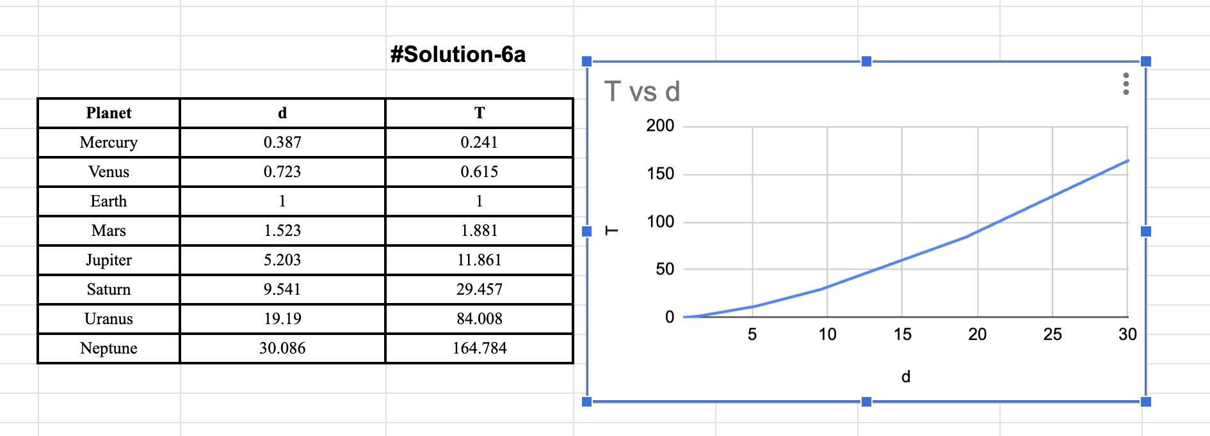

**#Solution-6b:**

Below is the graph that is passing through the origin. By Kepler’s Third law of planetary motion, T2 𝖺 𝑑3. Hence, the law is proven.

**#Solution-6c:**

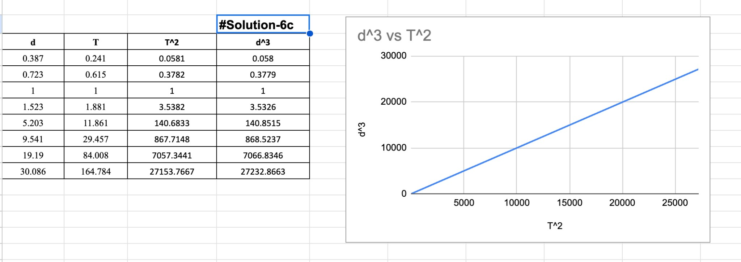

**#Question-7:**

**#Solution-7a:**

The graph of y = f(|x|) is obtained by taking the absolute value of the x-values in the function f(x). It reflects the portion of the graph of f(x) that lies in the positive x-axis to the negative x-axis. If x is positive, the coordinate point becomes (x, y).

However, if x is negative, the coordinate becomes(-x,y). The absolute function is related equatorially by; y = f(|x|) = f(x) if x is positive.

So, the graph of an absolute function is a reflection of the graph of f(x) at the y-axis when the value of x < 0 or negative.

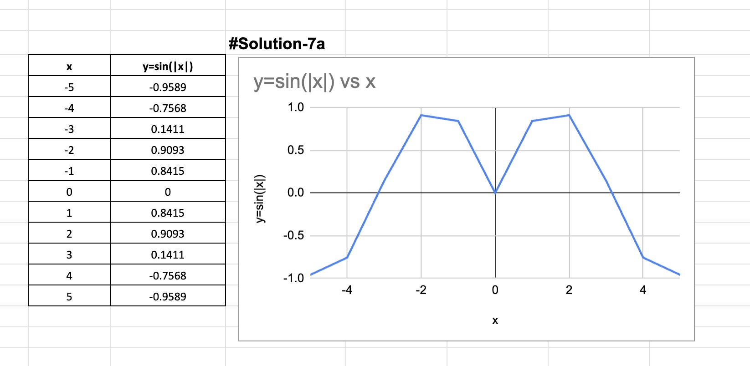

**#Solution-7b:**

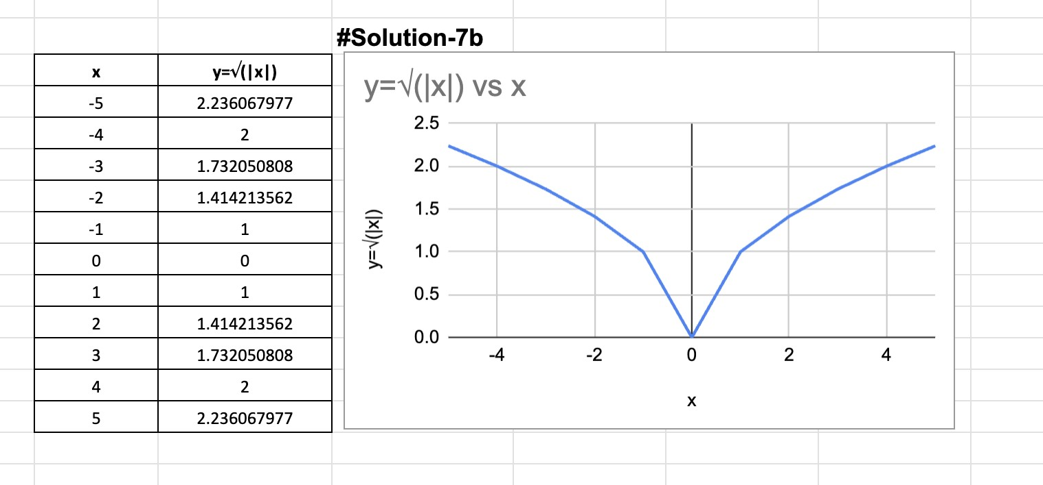

**#Question-8:**

**#Solutions**:

*a. (*𝑔 *○* 𝑓*) (6)* =g (f(6))

= g(6)

It is undefined because g is not defined at 6.

*b.(*𝑔 *○* 𝑔*)(−2)*

= g (g(-2))

= g(1)

= 4

*c. (*𝑓 *○* 𝑓*) (4)* = f (f(4))

= f (2)

= −2